Ex. No.: 6

Reg. No. : 210701092

**Importing JSON File and perform various Operations using HDFS and Python**

**emp.json:**

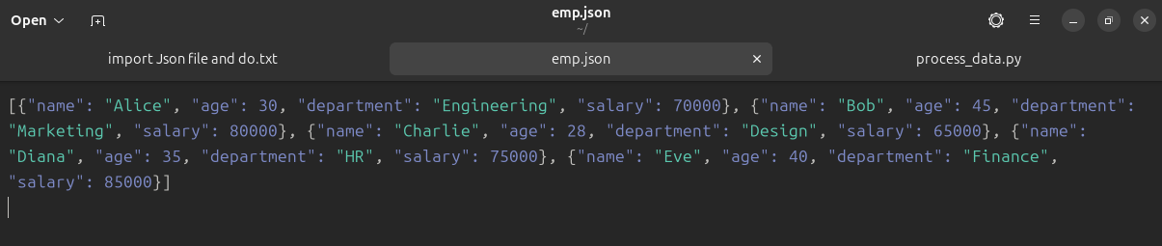

**process_data.py:**

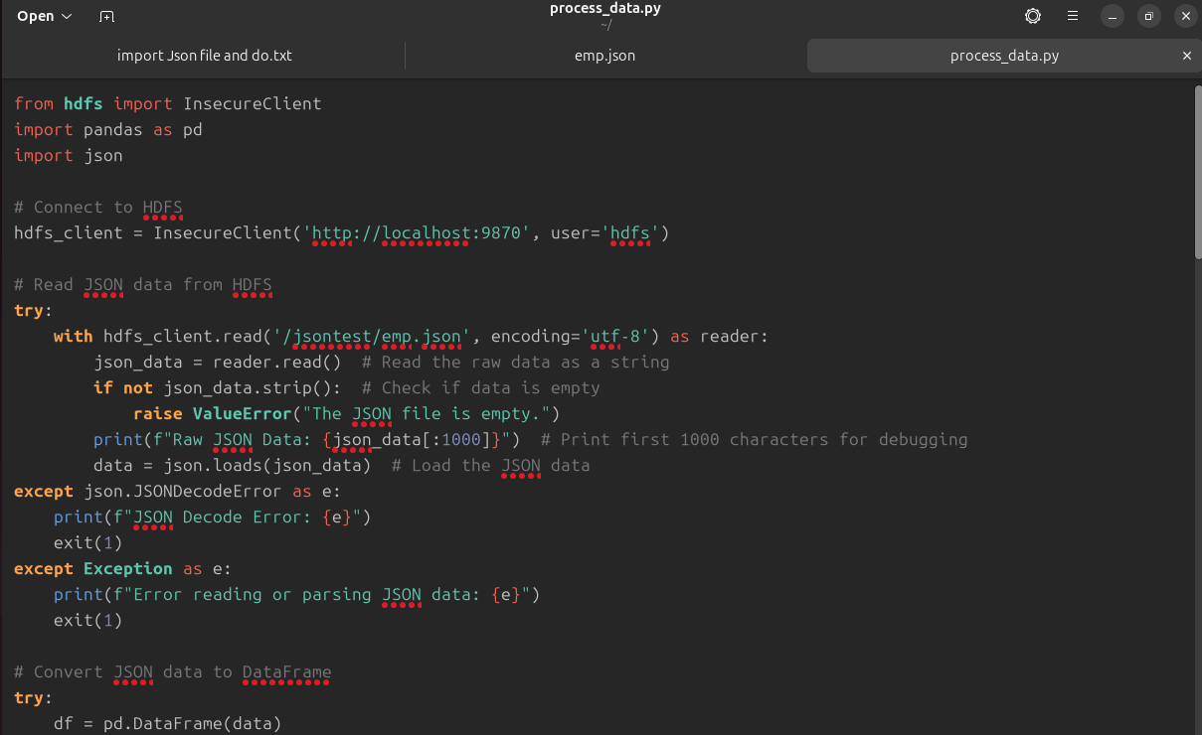

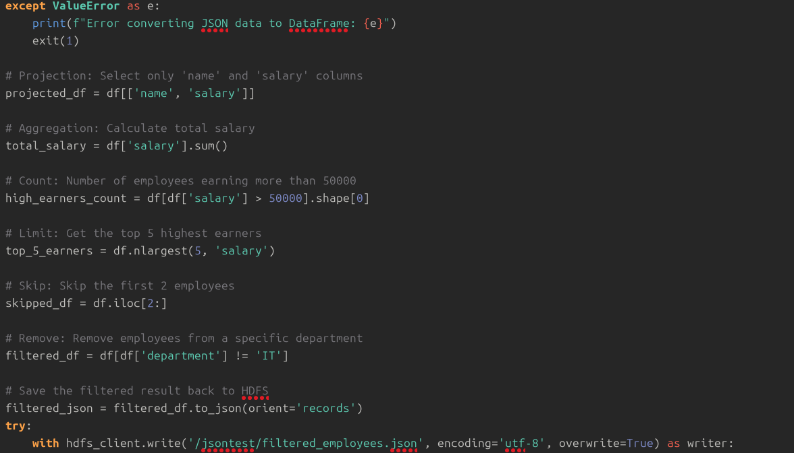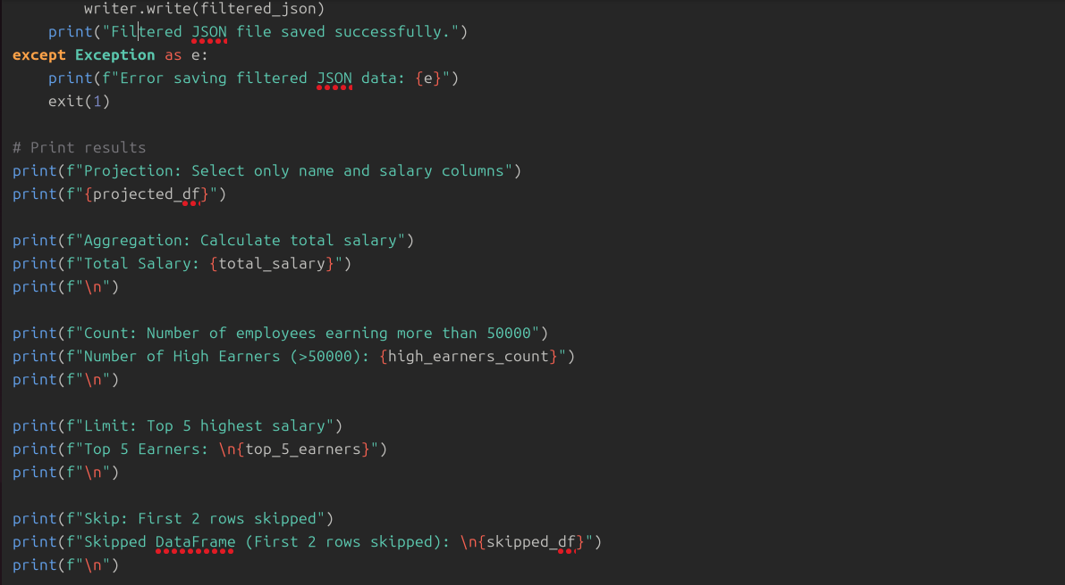

**Output:**



